Teacher Notes for “Coronaviruses – What They Are and How They Can Make You Sick”

In the shorter version of the Student Handout, students learn how coronaviruses are replicated inside our cells, how white blood cells fight a coronavirus infection, and how a coronavirus infection can cause you to feel sick. In the longer version of the Student Handout, students also learn how the respiratory and circulatory systems work together to provide oxygen to the body’s cells, and they learn how a coronavirus infection can interfere with oxygen delivery, which can result in severe disease.

It will be helpful if students have a basic understanding of proteins, RNA, ribosomes, and cells before they begin the activity. If your students need an introduction to these topics or a refresher, I recommend the video, “What Is DNA and How Does It Work?” (https://www.statedclearly.com/videos/what-is-dna/).

NGSS Learning Goals
In accord with the Next Generation Science Standards (NGSS):
- This activity helps students to prepare for Performance Expectation HS-LS1-2. “Develop and use a model to illustrate the hierarchical organization of interacting systems that provide specific functions within multicellular organisms.”
- This activity helps students to understand the Disciplinary Core Idea LS1.A. “Systems of specialized cells within organisms help them perform the essential functions of life .… Multicellular organisms have a hierarchical structural organization, in which anyone system is made up of numerous parts and is itself a component of the next level.”
- Students engage in two Scientific Practices:
  - “Constructing Explanations. Apply scientific ideas, principles and/or evidence to provide an explanation of phenomena…”
  - “Developing and Using Models. Develop… a model based on evidence to illustrate and/or predict the relationships between systems or between components of a system.”
- This activity helps students to understand the Crosscutting Concept, “Cause and Effect: Mechanism and Prediction. Cause and effect relationships can be suggested and predicted for complex natural… systems by examining what is known about smaller scale mechanisms within the system.”

Instructional Suggestions and Biology Background
The shorter version of the Student Handout may be more suitable if time is limited. The additional content in the longer version of the Student Handout is relevant for the NGSS Learning Goals. These Teacher Notes are relevant for both versions of the Student Handout, but the question numbers and page numbers refer to the longer version.

To maximize student participation and learning, I suggest that you have your students work individually or in pairs to complete each group of related questions and then have a class discussion after each group of questions. In each discussion, you can probe student thinking and help them develop a sound understanding of the concepts and information covered before moving on to the next group of related questions.

If your students are learning online, I recommend that they use the Google Doc version of the Student Handout available at https://serendipstudio.org/exchange/bioactivities/coronavirusintro. To answer questions 2a, 3 and 7, students can either print the relevant pages, draw on those and send you pictures, or they will need to know how to modify a drawing online. They can double-click on the relevant drawing in the Google Doc, which will open a drawing window. Then, they can use the editing tools to add lines, shapes, and text boxes. You may want to revise the GoogleDoc or Word document to prepare a version of the Student Handout that will be more suitable for your students; if you do this, please check the format by viewing the PDF.

A key is available upon request to Ingrid Waldron (iwaldron@upenn.edu). The following paragraphs provide additional instructional suggestions and background information – some for inclusion in your class discussions and some to provide you with relevant background that may be useful for your understanding and/or for responding to student questions.

A class discussion of student responses to question 1 will help you to understand your students’ current knowledge, including any misconceptions they may have. If your students have questions that will not be answered in this activity, you may want to use some of the coronavirus learning activities recommended at the end of these Teacher Notes.

Introduction to Coronaviruses
The novel coronavirus that is causing the current global pandemic is called SARS-Cov-2 because of its similarity to SARS-Cov, a coronavirus that caused an epidemic of Severe Acute Respiratory Syndrome in 2002-2004, mainly in Asia. The disease caused by SARS-Cov-2 is called Covid-19. CO stands for corona, VI stands for virus and D stands for disease; 19 stands for 2019, the year in which this disease was first identified. As of March 10, 2022, the estimated number of Covid-19 deaths was 964 thousand in the US and 6.02 million in the world (https://coronavirus.jhu.edu/region/united-states and https://coronavirus.jhu.edu/map.html; you may want to use these sources to check the number of deaths at the time you use this activity). Globally, reported Covid-19 deaths accounted for roughly 10% of all deaths during the pandemic, and a variety of evidence indicates that actual Covid-19 deaths were probably substantially higher (https://www.nature.com/articles/d41586-022-00104-8).

Covid-19 survivors often experience long-term symptoms and new diagnoses of other illnesses. Patients who had recovered from severe Covid-19 had a 2.5 times higher chance of dying during the next year than those who have not had Covid-19 (https://www.frontiersin.org/articles/10.3389/fmed.2021.778434/full). Roughly 20-40% of Covid-19 patients still had symptoms (e.g., fatigue) four or more weeks after their infection (https://www.medscape.com/viewarticle/963268; https://www.nature.com/articles/d41586-021-01511-z). Even for patients who had mild or asymptomatic Covid-19, about a quarter experience long-term symptoms (https://health.ucdavis.edu/news/headlines/studies-show-long-haul-covid-19-afflicts-1-in-4-covid-19-patients-regardless-of-severity/2021/03).

This image of a coronavirus shows a three-dimensional view on the left and a cross-sectional view on the right. The envelope of the coronavirus is similar to a cell membrane. The diameter of a coronavirus is roughly 100 nm, whereas the diameter of a human epithelial cell is roughly 50 µm or roughly 500 times bigger.

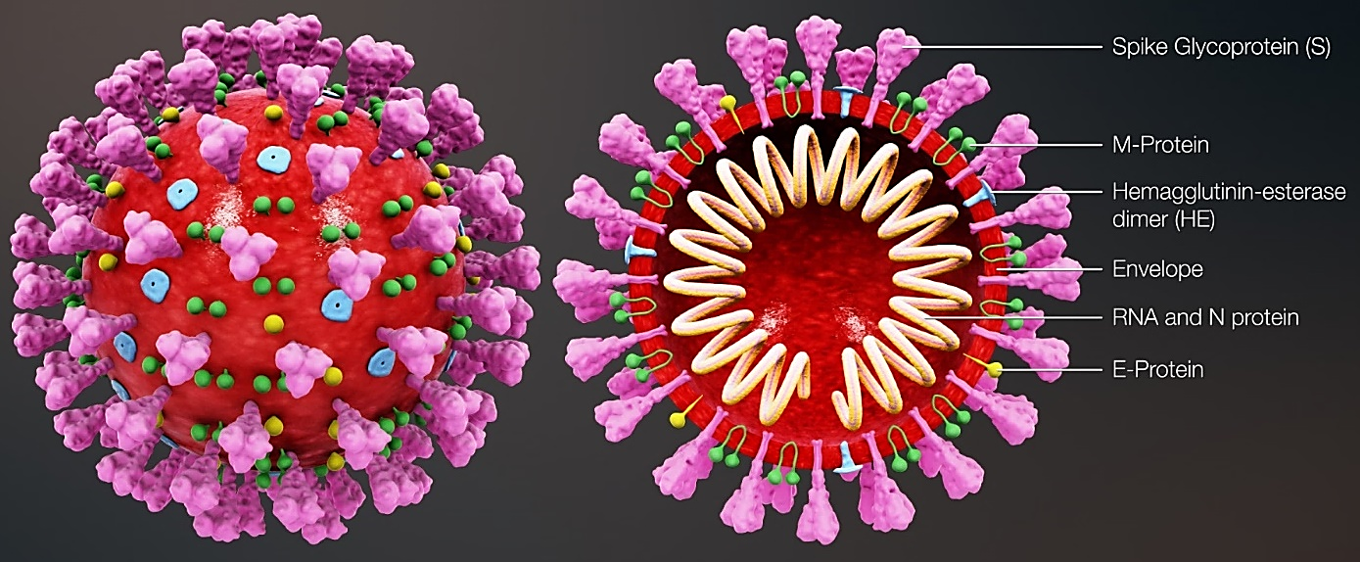

(https://upload.wikimedia.org/wikipedia/commons/9/96/3D_medical_animation_coronavirus_structure.jpg)

Most biologists consider viruses to be intermediate between living organisms and things that are not alive. Viruses cannot reproduce or use energy on their own, but they do evolve. For example, natural selection has played a crucial role in the evolution of more contagious variants of the coronavirus (see “Coronavirus Evolution and the COVID-19 Pandemic”, https://serendipstudio.org/exchange/bioactivities/coronavirusOrigin). Students should be aware of the difference between viruses and bacteria; bacteria are prokaryotic cells which can reproduce and use energy. Antibiotics can fight bacterial infections, but not viral infections.

Page 1 of the Student Handout recommends the video, “SARS-CoV-2 Infection” (https://media.hhmi.org/biointeractive/click/covid/infection.html) and the reading, “How coronaviruses replicate inside you” (https://www.latimes.com/projects/how-coronavirus-invade-cells-replicates/). If your students do not have access to the Internet, you can show them the video, and you can print copies of the reading. Alternatively, you can insert the figure below in the Student Handout.
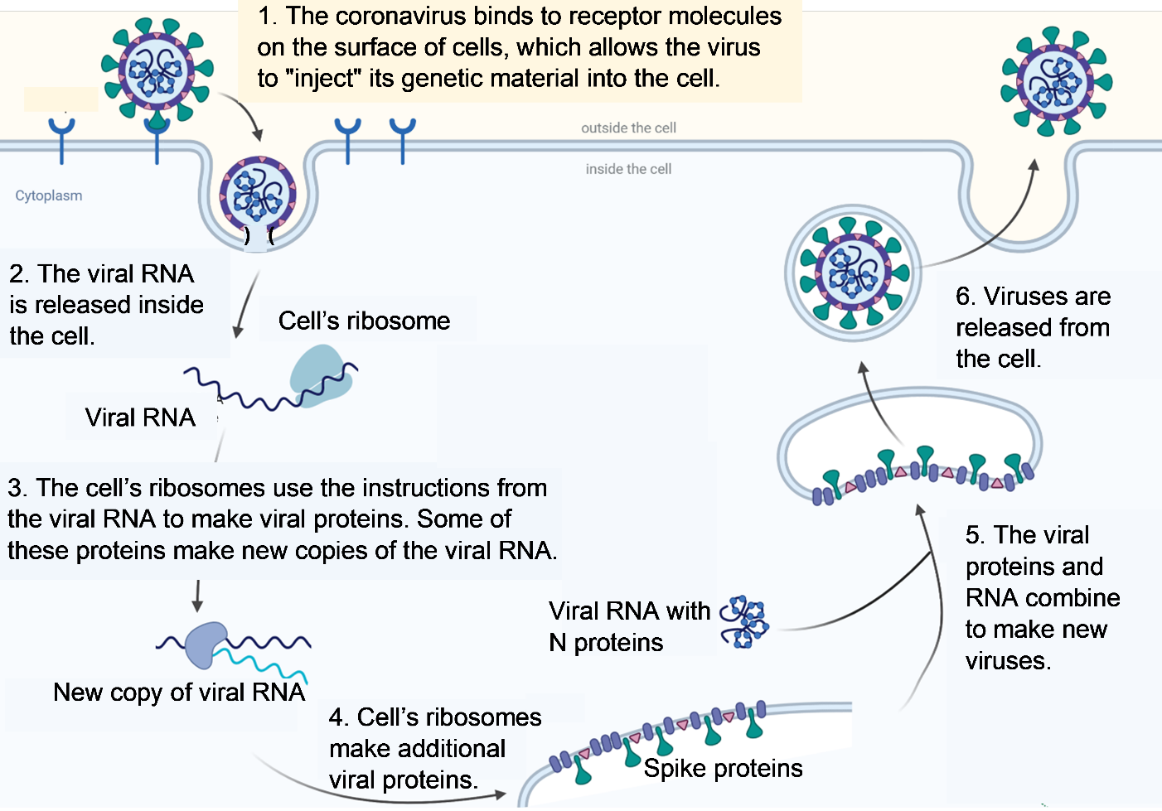
(Adapted from https://enviraltech.com/wp-content/uploads/2020/05/SARS-CoV-2-replication-2.png)

The coronavirus spike protein binds to a molecular receptor on the surface of cells in the nose, throat, lungs, and multiple other parts of the body. The figure below shows the two ways that coronavirus RNA can enter the cell. Both require an enzyme that cuts the spike protein (S2) to expose a fusion peptide which forms a fusion pore that allows the viral RNA to enter the cell cytoplasm. Many lung cells have an enzyme on the cell surface can make this cut; these cells use the cell surface entry shown on the right. Many nasal cells do not have this enzyme on their cell surface; these cells use the endosomal entry shown on the left.
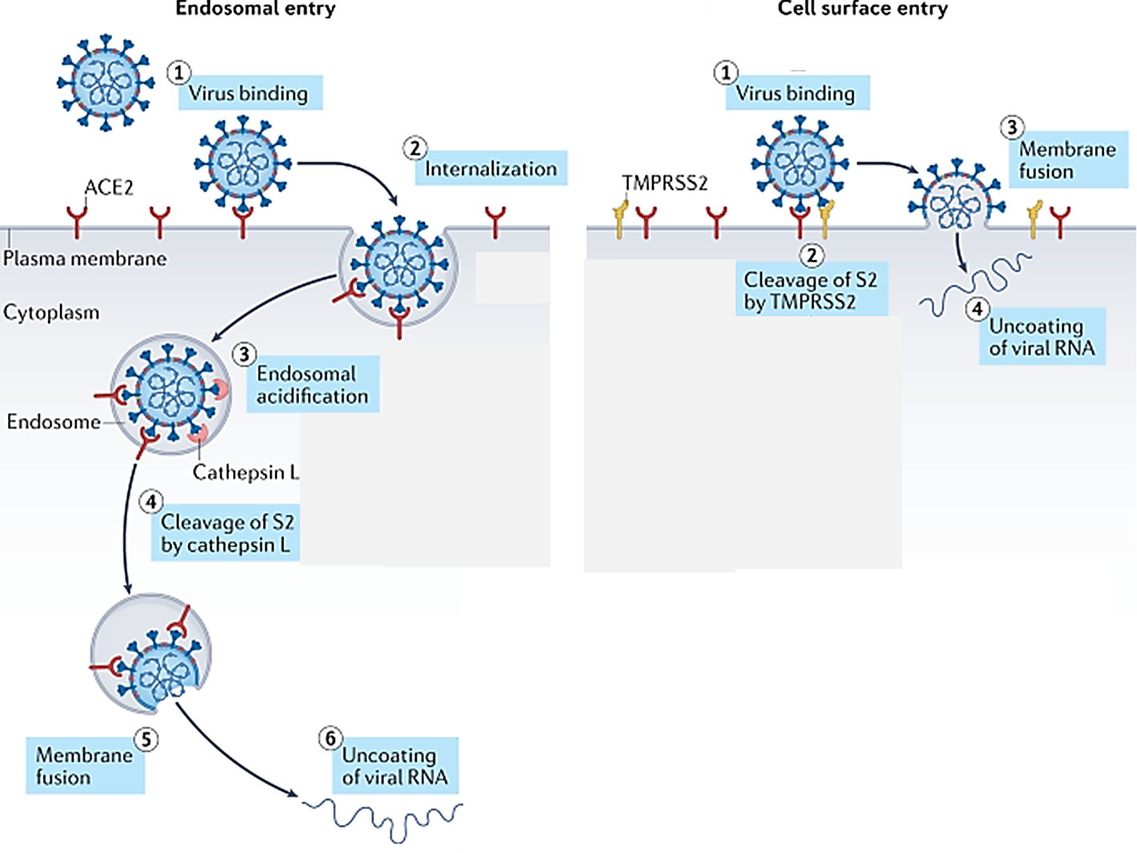
(Adapted from https://www.nature.com/articles/s41580-021-00418-x)

Coronavirus RNA serves as messenger RNA (mRNA). The cell’s ribosomes translate viral RNA to make viral proteins. A viral enzyme, RNA-dependent RNA polymerase, copies the viral RNA. Other viral proteins are inserted in an internal cell membrane that will become the viral envelope. The viral envelope, proteins and RNA assemble to form new viruses that are released from the infected cell, which typically dies.

After question 2, you may want to ask your students either or both of these questions:
- What happens to the new coronaviruses released by an infected cell?
- Why do our cells need ribosomes? What do ribosomes do in cells that are not infected with coronavirus?
The released viruses can infect other body cells, can be inactivated by the immune system, or can be spread to infect other people by coughing, sneezing, shouting, singing, talking or breathing. Students may benefit from a reminder that the ribosomes in our cells have a crucial role in the production of proteins coded for by the genes in our DNA.

If you want more information about the topics of this section, you can view minutes 8-26 of the informative video, “Coronavirus: How It Infects Us and How We Might Stop It” (https://www.scientificamerican.com/video/coronavirus-how-it-infects-us-and-how-we-might-stop-it/) and/or read “How the coronavirus infects cells – and why Delta is so dangerous” (https://www.nature.com/articles/d41586-021-02039-y) and/or “Mechanisms of SARS-CoV-2 entry into cells” (https://www.nature.com/articles/s41580-021-00418-x).

How can something so tiny make a person sick?
This section of the longer Student Handout provides a good opportunity to review levels of organization in biology with your students. For example, the top figure on page 2 of the Student Handout and question 3 can be used to review the importance of understanding biological structure and function at the levels of molecule, cell, organ and organ system. Question 4 will reinforce student understanding that interacting organ systems are needed to accomplish functions such as supplying all the body’s cells with oxygen.

At the bottom of page 2, the Student Handout recommends the first five minutes of the video, “What Happens If You Get Coronavirus” (https://www.youtube.com/watch?v=5DGwOJXSxqg). The first section of this video reviews the structure of the coronavirus and how the coronavirus replicates. The second section of the video explains the structure and function of the lungs and how pneumonia can develop. This section includes an explanation of how the lungs help to rid the body of carbon dioxide, a point which is not included in the Student Handout. The last section (which is not recommended) discusses vaccines and is somewhat out of date; e.g., the first two vaccines that were approved for use in the US are based on RNA, not weakened viruses as discussed in the video. For a more current discussion of vaccines, see “COVID-19 Vaccines – How do they work?” (https://serendipstudio.org/exchange/bioactivities/coronavirusvaccine).

Just before the end of the recommended first five minutes, this video states that “whether you would develop these symptoms depends on a lot of factors such as your age and whether you already have an existing condition”. Researchers are beginning to understand how these factors influence a person’s risk of severe coronavirus infection and death. For example, elderly people have decreased immune function which contributes to their increased risk. Also, advanced age and obesity are associated with reduced lung capacity which may make a person more vulnerable to the hypoxia produced by severe COVID-19 (https://www.thelancet.com/journals/lanres/article/PIIS2213-2600(21)00218-6/fulltext). Conditions such as obesity, diabetes, and cardiovascular disease are associated with inflammation of the lining of blood vessels; this exacerbates the harmful effects of inflammation in response to a coronavirus infection (https://khn.org/news/clots-strokes-and-rashes-is-covid-a-disease-of-the-blood-vessels/).

Inflammation refers to a cluster of innate, nonspecific responses to foreign invasion and/or tissue damage. These responses include increased capillary permeability which allows white blood cells and proteins to cross the capillary wall. As proteins move from the blood to the interstitial fluid, osmotic effects result in an increased volume of interstitial fluid. The influx of phagocytic white blood cells into the tissues around the capillaries helps to dispose of any infection (discussed in question 6). However, the accumulation of fluid in and around the alveoli interferes with diffusion of oxygen from the air in the alveoli into the blood (as discussed in question 7). The diffusion of gases in water is ~10⁴ times slower than the diffusion of gases in air (https://www.scielo.cl/scielo.php?script=sci_arttext&pid=S0718-58392015000300005).

The prose and figure on the bottom half of page 3 of the Student Handout describe some of the molecular, cellular, tissue and organ-level processes that contribute to severe COVID-19. Two types of cells are shown in the wall of the alveolus in the Student Handout figure.
- The very thin cells provide a minimum barrier to the diffusion of oxygen from the alveolus into the blood and carbon dioxide from the blood into the alveolus.
- The taller cells secrete surfactant, which reduces the surface tension of the water that lines the inside of each alveolus; this helps to prevent collapse of the alveoli.
Notice that many white blood cells have left the blood as part of the inflammatory response. Blood clots are a common feature of severe COVID-19. Blood clots are triggered by coronavirus in the endothelial cells that line the inside of blood vessels, as well as endothelial cell damage due to molecules released by the inflammatory response (https://www.thelancet.com/journals/lanres/article/PIIS2213-2600(21)00218-6/fulltext).

The figure below shows another view of the effects of inflammation on an alveolus. “Pulmonary edema” shows the fluid that accumulates in the alveoli. The “hyaline membrane” includes molecular debris and dead cells. Both pulmonary edema and the hyaline membrane interfere with diffusion of oxygen from the air in the alveolus to the blood in the capillaries. The influx of white blood cells (including monocytes and neutrophils) helps to fight the infection. The “pulmonary thrombus” is an example of blood clots that block or reduce blood flow and contribute significantly to the pathophysiology of coronavirus infections (https://elemental.medium.com/coronavirus-may-be-a-blood-vessel-disease-which-explains-everything-2c4032481ab2).

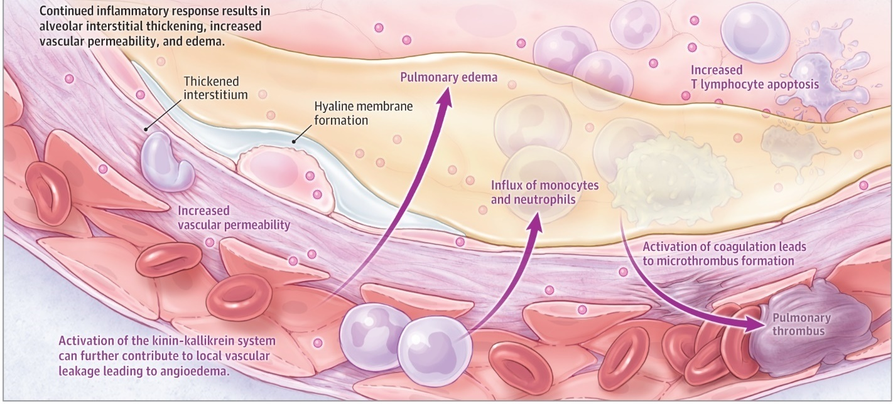
(https://jamanetwork.com/journals/jama/fullarticle/2768391)

You may want to relate the information about pathophysiology to some of the treatments for severe COVID-19. Dexamethasone is a corticosteroid that reduces inflammation. It can reduce the harmful effects of inflammation and has been shown to significantly increase survival in critically ill COVID-19 patients (https://www.medscape.com/viewarticle/936813). However, dexamethasone can also inhibit helpful immune responses, so it should only be given to appropriate patients. An immune treatment that helps some patients is antibody therapy (e.g., convalescent plasma or monoclonal antibodies; students are introduced to antibodies in “COVID-19 Vaccines – How do they work?” (https://serendipstudio.org/exchange/bioactivities/coronavirusvaccine)). The importance of blood clots is reinforced by the finding that anticoagulant drugs benefit hospitalized COVID-19 patients (https://www.nih.gov/news-events/news-releases/full-dose-blood-thinners-decreased-need-life-support-improved-outcome-hospitalized-covid-19-patients). Air is only 21% oxygen, so patients who are having trouble getting enough oxygen to the body’s cells can be helped by adding oxygen to the air they inhale. In extreme cases, a ventilator can help, but ventilators also have harmful effects, so they are generally used as a last resort.

One theme of pages 3 and 4 of the longer Student Handout (or page 2 of the shorter Student Handout) is that the immune system can have both beneficial and harmful effects during coronavirus infection. For example, inflammation opens gaps between the endothelial cells, which helps white blood cells and immune system proteins to reach the coronaviruses and infected cells, but the same gaps allow proteins and fluid to move into the tissue around the alveoli and into the lumens of the alveoli, which decreases the diffusion of oxygen into the blood. Similarly, fever and fatigue contribute both to feeling sick and fighting the infection.

This figure shows how the chemical messengers secreted by white blood cells (leukocytes) act on the hypothalamus in the brain to cause a fever. Increased set point refers to adjusting the negative feedback regulation of core body temperature to maintain a higher temperature. Vasoconstriction refers to decreased diameter of peripheral blood vessels, so less of the body’s heat is radiated from the skin. | 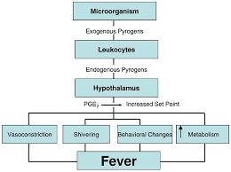  (https://encrypted-tbn0.gstatic.com/images?q=tbn:ANd9GcTgcqH-0HjYMMtKgc8dZEsPuVXGWxU4rO-G7Q&usqp=CAU)

Question 9 can be used for formative assessment. To answer this question, students should integrate and organize relevant information they have learned into a flowchart. Some students may benefit from additional scaffolding, e.g., providing a second box of the flowchart with the wording “Chemical signals”. Students may also benefit from collaborating in pairs to develop a flowchart. After students have completed their flowcharts, you can display several of them for the student creators to explain and the class to discuss. I recommend that you give your students prompt feedback, so they can improve the accuracy and completeness of their answers. Students will need a reasonable answer to question 9 in order to answer question 10, so you will probably want to have your class discussion of student answers to question 9, before they answer question 10.

To answer question 10, your students will build on their answers to question 9 and add relevant information from the Student Handout, including their answers to question 8. Again, you may want to have pairs of students prepare answers to be displayed and discussed.

After question 10, you may want to ask your students this Challenge Question.
As you have seen, much of the harm caused by a coronavirus infection is due to harmful effects of immune system responses. You may wonder whether you would be better off without any immune system. What would go wrong if you were infected with coronavirus and had no immune system?
In discussing this challenge question, you can point out that, without an immune system, the coronavirus could continue to multiply without any restraint; this would result in the destruction of many respiratory system cells, blood vessel endothelial cells, and other types of cells in the body. The damaged respiratory system cells would interfere with the diffusion of oxygen into the blood, and damaged endothelial cells in the lining of blood vessels would stimulate blood clots, which could cause heart attacks and stroke.

Sources for Student Handout Figures
- Figure of coronavirus structure, adapted from https://web.mit.edu/fnl/volume/324/king_etal.html
- Figure of respiratory system and alveolus, adapted from https://teachmeanatomy.info/wp-content/uploads/The-Bronchial-Tree.jpg and https://images.slideplayer.com/15/4628344/slides/slide_23.jpg
- Figure of circulatory system, adapted from https://s4.thingpic.com/images/85/zNiMHr2r5NxXEiuCcWJ5avYp.png
- Figure of white blood cell leaving capillary, adapted from https://useruploads.socratic.org/vcK6gAk8RiecQAjzBgtm_neutro.jpg
- Figure of inflammation effects on capillary and alveolus, adapted from https://coronavirusexplained.ukri.org/images/article/severe-covid-2.png

Follow-Up Activities
COVID-19 Vaccines – How do they work?
https://serendipstudio.org/exchange/bioactivities/coronavirusvaccine
Students begin by proposing a hypothesis to explain why the risk of severe Covid-19 is substantially lower for people who have been vaccinated and for people who have previously had Covid-19. Next, students analyze the immune system response to a coronavirus infection and learn how this response differs after a first vs. second exposure to the coronavirus. Finally, students analyze the biological effects of an mRNA vaccine and develop an evidence-based hypothesis about how a vaccine protects against severe Covid-19.

How to Reduce the Spread of COVID-19
https://serendipstudio.org/exchange/bioactivities/coronavirusprev
In this activity, students analyze information about how the coronavirus is transmitted and how to reduce the risk of coronavirus infection. Several questions engage students in thinking about how their behavior influences the risk of COVID-19 for more vulnerable individuals.

Coronavirus Evolution and the COVID-19 Pandemic
https://serendipstudio.org/exchange/bioactivities/coronavirusOrigin
In this analysis and discussion activity, students learn how a spillover infection could have produced the Covid-19 pandemic. Students analyze the contributions of mutations and natural selection to a spillover infection. Next, students learn how natural selection increased the frequency of a mutation that made the coronavirus more contagious. Finally, students analyze how mutations and natural selection contributed to the origin and spread of the Omicron variant.

Resources for Teaching about Coronavirus
https://serendipstudio.org/exchange/bioactivities/coronavirus
This webpage has compiled information about learning activities and other resources for teaching high school biology students about the coronavirus and COVID-19.

If your students have additional questions about the novel coronavirus and the COVID-19 pandemic, you may want to encourage them to research these questions using the following sources of reliable information.
- Coronavirus (COVID-19) (https://www.cdc.gov/coronavirus/2019-ncov/index.html)
- Science (https://www.sciencenews.org/editors-picks/2019-novel-coronavirus-outbreak)
- New York Times (https://www.nytimes.com/news-event/coronavirus)

By Dr. Ingrid Waldron, Department of Biology, University of Pennsylvania, 2022. These Teacher Notes and the related Student Handout are available at https://serendipstudio.org/exchange/bioactivities/coronavirusintro.
Quotations are from NGSS "High School Life Sciences" at http://www.nextgenscience.org/sites/default/files/HS%20LS%20topics%20combined%206.13.13.pdf
To draw a line - At the top of the page, find Select line and pick the type of line you want. - Place the line on your drawing: - Line, Elbow Connector, Curved Connector or Arrow: Click to start, then drag across the canvas. - Curve or Polyline: Click to start, then click at each point you want the line to bend. Double-click or complete the shape to finish. - Scribble: Click to start, then drag across the canvas. To draw a shape - At the top of the page, find and click Shape. - Choose the shape you want to use. - Click and drag on the canvas to draw your shape. To insert text - At the top of the page, click Insert. - To place text inside a box or confined area, click Text Box and drag it to where you want it. - Type your text. - You can select, resize and format the word art or text box, or apply styles like bold or italics to the text. When you are done, click Save and Close.
The coronavirus spike is actually a glycoprotein. It binds to ACE2, which is angiotensin-converting enzyme 2. This enzyme is found on the surface of many body cells, including alveolar cells and blood vessel endothelial cells. ACE2 has important roles in body physiology, and the harmful effects of the coronavirus may be partly due to inhibition of these roles (https://www.frontiersin.org/articles/10.3389/fcimb.2020.00317/full).
If you are using the shorter Student Handout, suggestions for scaffolding to help your students answer question 5 are given on page 8 of these Teacher Notes in the paragraph that discusses question 9 in the longer Student Handout.
In this video, the description and image of the proteins that protect the viral RNA is inaccurate; see figure on page 1 of the Student Handout.
Inflammation can be local and short-term (e.g., the localized swelling, redness and heat after a splinter or cut) or inflammation can be more widespread and/or chronic (https://www.medicalnewstoday.com/articles/248423; https://onlinelearning.hms.harvard.edu/hmx/immunity/, see the section on innate immune responses).
Some businesses and organizations are using temperature checks to screen patrons, but many people who are infected and can spread the coronavirus do not have a fever, so this is probably not an effective way of reducing the spread of coronavirus.
If your class is meeting online, you can use Google Jamboard for this purpose. If you are using Jamboard and you feel your students need considerable scaffolding, you could even provide several sticky notes with some of the immune system responses for students to organize as they begin their flowchart. If your class is meeting in person, you can have small groups of students collaborate to draw their flowcharts on whiteboards. For information about how to make inexpensive whiteboards and use them in your teaching, see "The $2 interactive whiteboard" and "Resources for whiteboarding" in https://fnoschese.wordpress.com/2010/08/06/the-2-interactive-whiteboard/. You can go to Home Depot and ask them to cut a 8' x 4' whiteboard (e.g. EUCATILE Hardboard Thrifty White Tile Board) into six pieces with the dimension 32" x 24". They should have a power saw rig that allows their employees to cut the pieces very easily. They should not charge to cut them and the product cost is reasonable. Some additional tips are: – Coat the white boards with Endust (or similar product) before using. Every once in a while wipe them clean and reapply Endust. – Do not use markers that are old or almost empty. The ink from these are more difficult to erase. – Black markers erase easiest. – Best if boards are erased immediately after use. – Teacher and/or students can take a picture of the information on the board if they want to save it.

